**Install setup for given Demo Assignment**

**Work environment**

**Operating System: Windows 7 64 bit**

**RAM: 8 GB**

**Hard Disk: 250 GB**

Install python: 2.7.14:-- Install python which is an open source platform independent

Eclipse Neon IDLE with pyDev package for running the scripts

Pip latest version

Install supporting python package using pip for the flowing tools by using pip command

Navigate to cmd prompt and install following by given command

1. Flask: pip install Flask
2. Requests : pip install requests
3. Jsonify: pip install jsonify

url_for & redirect is not used in this package for this demo if required used the same command,’ url_for ‘ & ‘redirect ‘ is used for web navigation

Once the above software is successfully configured , we can run the “Demo_app.py” for running the server by command prompt shown below

Cmd: -- python demo_app.py

Once the service is on , hit the request with below url in the chrome browser and below screen should be displayed

1. **URI - http://localhost:5000/**

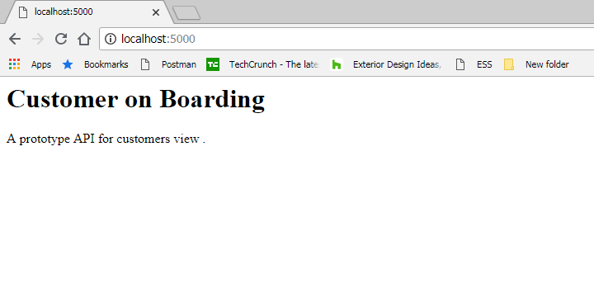

**Come back to scripts configuration -> Navigate to Module folder (Customer.py and APIservices.py file should be visible)**

Open Customer.py in IDLE - > we have 2 import package listed below

1. APIservices : which executes the file which are requested with REST services
2. Unittest : we used basically for Code coverage as of now

For running the Code Coverage, we used Coverage Tool, which basically covers the code usage

Install: pip install coverage (which should install the coverage package on the python)

Using coverage we can extract the report in both dos mode as well in the HTML format

You can refer more from coverage help document enclosed in the project

Running command

Navigate to Customer.py file path from the command prompt and run the blow command

1. coverage run Customer.py : which will execute the coverage test on customer.py script
2. coverage report –m: which will generate the report along with included files in the dos mode
3. coverage html : which generate the HTML report and placed in the current path